**Design the memory map and memory decoder for a 16 bits microprocessor system using the following memory requirements:**

**- 256KB EEPROM ending at FFFFFH, using 64K x 16 bits memories**

**- 128KB DRAM, using 32K x 8 bits memories**

**STEP 1**

$$EEPROM \# circuits = \frac{256 KB}{64 K * 16 bits}=2$$

$$DRAM \# circuits = \frac{128 KB}{32 K * 8 bits}=4$$

**STEP 2**

$$EEPROM \#\frac{circuits}{block}=\frac{16}{16}=1$$

$$EEPROM \# blocks=\frac{2}{1}=2→B1, B2$$

$$DRAM \#\frac{circuits}{block}=\frac{16}{8}=2$$

$$DRAM \# blocks=\frac{4}{2}=2→B3, B4$$

**STEP 3**

|  |  |  |  |  |
| --- | --- | --- | --- | --- |
| ***BLOCK*** | ***BLOCK SIZE*** | ***ADDRESS LINES*** | ***ADDRESS RANGE*** | |
| B1 | 128 KB | 17 | 0x0_0000 | 0x1_FFFF |
| B2 | 128 KB | 17 | 0x0_0000 | 0x1_FFFF |
| B3 | 64 KB | 16 | 0x0000 | 0xFFFF |
| B4 | 64 KB | 16 | 0x0000 | 0xFFFF |

**STEP 4**

|  |  |  |
| --- | --- | --- |
| ***TYPE*** | ***BLOCK*** | ***MEMORY MAP*** |
| DRAM | B3 | 0x0_0000 |
| 0x0_FFFF |
| B4 | 0x1_0000 |
| 0x1_FFFF |
| . . . | | |
| EEPROM | B1 | 0xC_0000 |
| 0xD_FFFF |
| B2 | 0xE_0000 |
| 0xF_FFFF |

**STEP 5**

|  |  |  |  |  |  |  |  |  |  |
| --- | --- | --- | --- | --- | --- | --- | --- | --- | --- |
| ***A19*** | ***A18*** | ***A17*** | ***A16*** | ***A15*** | ***A14*** | ***...*** | ***A1*** | ***A0*** |  |
| 1 | 1 | 0 | 0 | 0 | 0 | ... | 0 | 0 | ***B1*** |
| 1 | 1 | 0 | 1 | 1 | 1 | 1 | 1 |
| 1 | 1 | 1 | 0 | 0 | 0 | 0 | 0 | ***B2*** |
| 1 | 1 | 1 | 1 | 1 | 1 | 1 | 1 |
| 0 | 0 | 0 | 0 | 0 | 0 | 0 | 0 | ***B3*** |
| 0 | 0 | 0 | 0 | 1 | 1 | 1 | 1 |
| 0 | 0 | 0 | 1 | 0 | 0 | 0 | 0 | ***B4*** |
| 0 | 0 | 0 | 1 | 1 | 1 | 1 | 1 |

**STEP 6**

$$\overline{C_{S1}}=\overline{A_{19}∙A_{18}∙\overline{A_{17}}}$$

$$\overline{C_{S2}}=\overline{A_{19}∙A_{18}∙A_{17}}$$

$$\overline{C_{S3}}=\overline{\overline{A_{19}}∙\overline{A_{18}}∙\overline{A_{17}}∙\overline{A_{16}}}$$

$$\overline{C_{S4}}=\overline{\overline{A_{19}}∙\overline{A_{18}}∙\overline{A_{17}}∙A_{16}}$$

**STEP 7**



**3-TO-8**

**DECODER**

**B3**

**B4**

**B2**

**B1**



**Design the memory map and memory decoder for a 16 bits microprocessor system using the following memory requirements:**

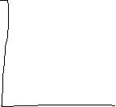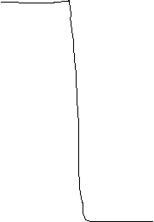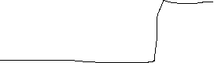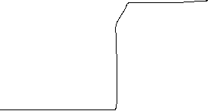

**- 256KB EEPROM starting at 40000H, using 64K x 8 bits memories**

**- 256KB DRAM, using 64K x 1 bit memories**

**STEP 1**

$$EEPROM \# circuits = \frac{256 KB}{64 K * 8 bits}=4$$

$$DRAM \# circuits = \frac{256 KB}{64 K * 1 bits}=32$$

**STEP 2**

$$EEPROM \#\frac{circuits}{block}=\frac{16}{1}=16$$

$$EEPROM \# blocks=\frac{32}{16}=2→B1, B2$$

$$DRAM \#\frac{circuits}{block}=\frac{16}{8}=2$$

$$DRAM \# blocks=\frac{4}{2}=2→B3, B4$$

**STEP 3**

|  |  |  |  |  |
| --- | --- | --- | --- | --- |
| ***BLOCK*** | ***BLOCK SIZE*** | ***ADDRESS LINES*** | ***ADDRESS RANGE*** | |
| B1 | 128 KB | 17 | 0x0_0000 | 0x1_FFFF |
| B2 | 128 KB | 17 | 0x0_0000 | 0x1_FFFF |
| B3 | 128 KB | 17 | 0x0_0000 | 0x1_FFFF |
| B4 | 128 KB | 17 | 0x0_0000 | 0x1_FFFF |

**STEP 4**

|  |  |  |
| --- | --- | --- |
| ***TYPE*** | ***BLOCK*** | ***MEMORY MAP*** |
| DRAM | B3 | 0x0_0000 |
| 0x1_FFFF |
| B4 | 0x2_0000 |
| 0x3_FFFF |
| EEPROM | B1 | 0x4_0000 |
| 0x5_FFFF |
| B2 | 0x6_0000 |
| 0x7_FFFF |

**STEP 5**

|  |  |  |  |  |  |  |  |  |  |
| --- | --- | --- | --- | --- | --- | --- | --- | --- | --- |
| ***A19*** | ***A18*** | ***A17*** | ***A16*** | ***A15*** | ***A14*** | ***...*** | ***A1*** | ***A0*** |  |
| 0 | 0 | 0 | 0 | 0 | 0 | ... | 0 | 0 | ***B3*** |
| 0 | 0 | 0 | 1 | 1 | 1 | 1 | 1 |
| 0 | 0 | 1 | 0 | 0 | 0 | 0 | 0 | ***B4*** |
| 0 | 0 | 1 | 1 | 1 | 1 | 1 | 1 |
| 0 | 1 | 0 | 0 | 0 | 0 | 0 | 0 | ***B1*** |
| 0 | 1 | 0 | 1 | 1 | 1 | 1 | 1 |
| 0 | 1 | 1 | 0 | 0 | 0 | 0 | 0 | ***B2*** |
| 0 | 1 | 1 | 1 | 1 | 1 | 1 | 1 |

**STEP 6**

$$\overline{C_{S1}}=\overline{\overline{A_{19}}∙A_{18}∙\overline{A_{17}}}$$

$$\overline{C_{S2}}=\overline{A_{19}∙\overline{A_{18}}∙\overline{A_{17}}}$$

$$\overline{C_{S3}}=\overline{\overline{A_{19}}∙\overline{A_{18}}∙\overline{A_{17}}}$$

$$\overline{C_{S4}}=\overline{\overline{A_{19}}∙\overline{A_{18}}∙A_{17}}$$

**STEP 7**



**3-TO-8**

**DECODER**

**B3**

**B4**

**B2**

**B1**

**Design the memory map and memory decoder for a 16 bits microprocessor system using the following memory requirements:**

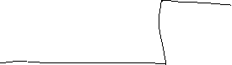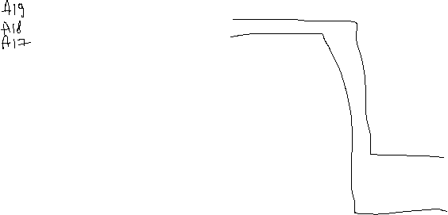

**- 128KB EEPROM, using 64K x 8 bits memories**

**- 512KB DRAM, using 64K x 8 bits memories**

**STEP 1**

$$EEPROM \# circuits = \frac{128 KB}{64 K * 8 bits}=2$$

$$DRAM \# circuits = \frac{512 KB}{64 K * 8 bits}=8$$

**STEP 2**

$$EEPROM \#\frac{circuits}{block}=\frac{16}{8}=2$$

$$EEPROM \# blocks=\frac{2}{2}=1→B1$$

$$DRAM \#\frac{circuits}{block}=\frac{16}{8}=2$$

$$DRAM \# blocks=\frac{8}{2}=4→B2, B3,B4,B5$$

**STEP 3**

|  |  |  |  |  |
| --- | --- | --- | --- | --- |
| ***BLOCK*** | ***BLOCK SIZE*** | ***ADDRESS LINES*** | ***ADDRESS RANGE*** | |
| B1 | 128 KB | 17 | 0x0_0000 | 0x1_FFFF |
| B2 | 128 KB | 17 | 0x0_0000 | 0x1_FFFF |
| B3 | 128 KB | 17 | 0x0_0000 | 0x1_FFFF |
| B3 | 128 KB | 17 | 0x0_0000 | 0x1_FFFF |
| B3 | 128 KB | 17 | 0x0_0000 | 0x1_FFFF |

**STEP 4**

|  |  |  |
| --- | --- | --- |
| ***TYPE*** | ***BLOCK*** | ***MEMORY MAP*** |
| EEPROM | B1 | 0x0_0000 |
| 0x1_FFFF |
| DRAM | B2 | 0x2_0000 |
| 0x3_FFFF |
| B3 | 0x4_0000 |
| 0x5_FFFF |
| B4 | 0X6_0000 |
| 0x7_FFFF |
| B5 | 0x8_0000 |
| 0x9_FFFF |

**STEP 5**

|  |  |  |  |  |  |  |  |  |  |
| --- | --- | --- | --- | --- | --- | --- | --- | --- | --- |
| ***A19*** | ***A18*** | ***A17*** | ***A16*** | ***A15*** | ***A14*** | ***...*** | ***A1*** | ***A0*** |  |
| 0 | 0 | 0 | 0 | 0 | 0 | ... | 0 | 0 | ***B1*** |
| 0 | 0 | 0 | 1 | 1 | 1 | 1 | 1 |
| 0 | 0 | 1 | 0 | 0 | 0 | 0 | 0 | ***B2*** |
| 0 | 0 | 1 | 1 | 1 | 1 | 1 | 1 |
| 0 | 1 | 0 | 0 | 0 | 0 | 0 | 0 | ***B3*** |
| 0 | 1 | 0 | 1 | 1 | 1 | 1 | 1 |
| 0 | 1 | 1 | 0 | 0 | 0 | 0 | 0 | ***B4*** |
| 0 | 1 | 1 | 1 | 1 | 1 | 1 | 1 |
| 1 | 0 | 0 | 0 | 0 | 0 | 0 | 0 | ***B5*** |
| 1 | 0 | 0 | 1 | 1 | 1 | 1 | 1 |

**STEP 6**

$$\overline{C_{S1}}=\overline{\overline{A_{19}}∙\overline{A_{18}}∙\overline{A_{17}}}$$

$$\overline{C_{S2}}=\overline{\overline{A_{19}}∙\overline{A_{18}}∙A_{17}}$$

$$\overline{C_{S3}}=\overline{\overline{A_{19}}∙A_{18}∙\overline{A_{17}}}$$

$$\overline{C_{S4}}=\overline{\overline{A_{19}}∙A_{18}∙A_{17}}$$

$$\overline{C_{S5}}=\overline{A_{19}∙\overline{A_{18}}∙\overline{A_{17}}}$$

**STEP 7**



**3-TO-8**

**DECODER**

**B3**

**B4**

**B2**

**B1**

**Design the memory map and memory decoder for a 16 bits microprocessor system using the following memory requirements:**



**B5**

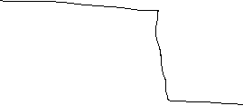

**- 64KB EEPROM ending at FFFFFH, using 16K x 16 bits memories**

**- 64KB DRAM, starting at 00000h, using 32K x 8 bits memories**

**STEP 1**

$$EEPROM \# circuits = \frac{64 KB}{16 K * 16 bits}=2$$

$$DRAM \# circuits = \frac{64 KB}{32 K * 8 bits}=2$$

**STEP 2**

$$EEPROM \#\frac{circuits}{block}=\frac{16}{16}=1$$

$$EEPROM \# blocks=\frac{2}{1}=2→B1, B2$$

$$DRAM \#\frac{circuits}{block}=\frac{16}{8}=2$$

$$DRAM \# blocks=\frac{2}{2}=1→B3$$

**STEP 3**

|  |  |  |  |  |
| --- | --- | --- | --- | --- |
| ***BLOCK*** | ***BLOCK SIZE*** | ***ADDRESS LINES*** | ***ADDRESS RANGE*** | |
| B1 | 32 KB | 15 | 0x0000 | 0x7FFF |
| B2 | 32 KB | 15 | 0x0000 | 0x7FFF |
| B3 | 64 KB | 16 | 0x0000 | 0xFFFF |

**STEP 4**

|  |  |  |
| --- | --- | --- |
| ***TYPE*** | ***BLOCK*** | ***MEMORY MAP*** |
| DRAM | B3 | 0x0_0000 |
| 0x0_FFFF |
| . . . | | |
| EEPROM | B1 | 0xF_0000 |
| 0xF_7FFF |
| B2 | 0xF_8000 |
| 0xF_FFFF |

**STEP 5**

|  |  |  |  |  |  |  |  |  |  |  |  |
| --- | --- | --- | --- | --- | --- | --- | --- | --- | --- | --- | --- |
| ***A19*** | ***A18*** | ***A17*** | ***A16*** | ***A15*** | ***A14*** | ***A13*** | ***A12*** | ***...*** | ***A1*** | ***A0*** |  |
| 1 | 1 | 1 | 1 | 0 | 0 | 0 | 0 | ... | 0 | 0 | ***B1*** |
| 1 | 1 | 1 | 1 | 0 | 1 | 1 | 1 | 1 | 1 |
| 1 | 1 | 1 | 1 | 1 | 0 | 0 | 0 | 0 | 0 | ***B2*** |
| 1 | 1 | 1 | 1 | 1 | 1 | 1 | 1 | 1 | 1 |
| 0 | 0 | 0 | 0 | 0 | 0 | 0 | 0 | 0 | 0 | ***B3*** |
| 0 | 0 | 0 | 0 | 1 | 1 | 1 | 1 | 1 | 1 |

**STEP 6**

$$\overline{C_{S1}}=\overline{A_{19}∙A_{18}∙A_{17}∙A_{16}∙\overline{A_{15}}}$$

$$\overline{C_{S2}}=\overline{A_{19}∙A_{18}∙A_{17}∙A_{16}∙A_{15}}$$

$$\overline{C_{S3}}=\overline{\overline{A_{19}}∙\overline{A_{18}}∙\overline{A_{17}}∙\overline{A_{16}}}$$

**STEP 7**



**3-TO-8**

**DECODER**

**B3**

**B2**

**B1**



**Design the memory map and memory decoder for a 16 bits microprocessor system using the following memory requirements:**

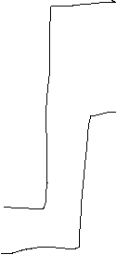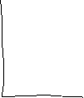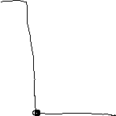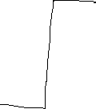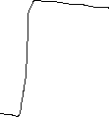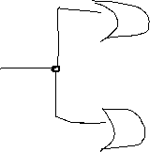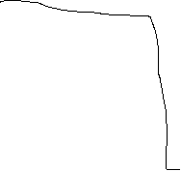

**- 256KB EEPROM ending at 7ffffH, using 32K x 16 bits memories**

**- 256KB DRAM, using 64K x 8 bits memories**

**STEP 1**

$$EEPROM \# circuits = \frac{256 KB}{32 K * 16 bits}=4$$

$$DRAM \# circuits = \frac{256 KB}{64 K * 8 bits}=4$$

**STEP 2**

$$EEPROM \#\frac{circuits}{block}=\frac{16}{16}=1$$

$$EEPROM \# blocks=\frac{4}{1}=4→B1, B2,B3,B4$$

$$DRAM \#\frac{circuits}{block}=\frac{16}{8}=2$$

$$DRAM \# blocks=\frac{4}{2}=2→B5, B6$$

**STEP 3**

|  |  |  |  |  |
| --- | --- | --- | --- | --- |
| ***BLOCK*** | ***BLOCK SIZE*** | ***ADDRESS LINES*** | ***ADDRESS RANGE*** | |
| B1 | 64 KB | 16 | 0x0000 | 0xFFFF |
| B2 | 64 KB | 16 | 0x0000 | 0xFFFF |
| B3 | 64 KB | 16 | 0x0000 | 0xFFFF |
| B4 | 64 KB | 16 | 0x0000 | 0xFFFF |
| B5 | 128 KB | 17 | 0x0_0000 | 0x1_FFFF |
| B6 | 128 KB | 17 | 0x0_0000 | 0x1_FFFF |

**STEP 4**

|  |  |  |
| --- | --- | --- |
| ***TYPE*** | ***BLOCK*** | ***MEMORY MAP*** |
| DRAM | B5 | 0x0_0000 |
| 0x1_FFFF |
| B6 | 0x2_0000 |
| 0x3_FFFF |
| EEPROM | B1 | 0x4_0000 |
| 0x4_FFFF |
| B2 | 0x5_0000 |
| 0x5_FFFF |
| B3 | 0x6_0000 |
| 0x6_FFFF |
| B4 | 0x7_0000 |
| 0x7_FFFF |

**STEP 5**

|  |  |  |  |  |  |  |  |  |  |
| --- | --- | --- | --- | --- | --- | --- | --- | --- | --- |
| ***A19*** | ***A18*** | ***A17*** | ***A16*** | ***A15*** | ***A14*** | ***...*** | ***A1*** | ***A0*** |  |
| 0 | 0 | 0 | 0 | 0 | 0 | ... | 0 | 0 | ***B5*** |
| 0 | 0 | 0 | 1 | 1 | 1 | 1 | 1 |
| 0 | 0 | 1 | 0 | 0 | 0 | 0 | 0 | ***B6*** |
| 0 | 0 | 1 | 1 | 1 | 1 | 1 | 1 |
| 0 | 1 | 0 | 0 | 0 | 0 | 0 | 0 | ***B1*** |
| 0 | 1 | 0 | 0 | 1 | 1 | 1 | 1 |
| 0 | 1 | 0 | 1 | 0 | 0 | 0 | 0 | ***B2*** |
| 0 | 1 | 0 | 1 | 1 | 1 | 1 | 1 |
| 0 | 1 | 1 | 0 | 0 | 0 | 0 | 0 | ***B3*** |
| 0 | 1 | 1 | 0 | 1 | 1 | 1 | 1 |
| 0 | 1 | 1 | 1 | 0 | 0 | 0 | 0 | ***B4*** |
| 0 | 1 | 1 | 1 | 1 | 1 | 1 | 1 |

**STEP 6**

$$\overline{C_{S1}}=\overline{\overline{A_{19}}∙A_{18}∙\overline{A_{17}}∙\overline{A_{16}}}$$

$$\overline{C_{S2}}=\overline{\overline{A_{19}}∙A_{18}∙\overline{A_{17}}∙A_{16}}$$

$$\overline{C_{S3}}=\overline{\overline{A_{19}}∙A_{18}∙A_{17}∙\overline{A_{16}}}$$

$$\overline{C_{S4}}=\overline{\overline{A_{19}}∙A_{18}∙A_{17}∙A_{16}}$$

$$\overline{C_{S5}}=\overline{\overline{A_{19}}∙\overline{A_{18}}∙\overline{A_{17}}}$$

$$\overline{C_{S6}}=\overline{\overline{A_{19}}∙\overline{A_{18}}∙A_{17}}$$

**STEP 7**

**B1**



**3-TO-8**

**DECODER**

**Design the memory map and memory decoder for a 16 bits microprocessor system using the following memory requirements:**

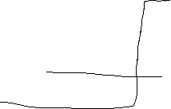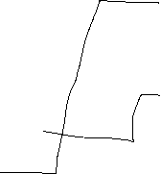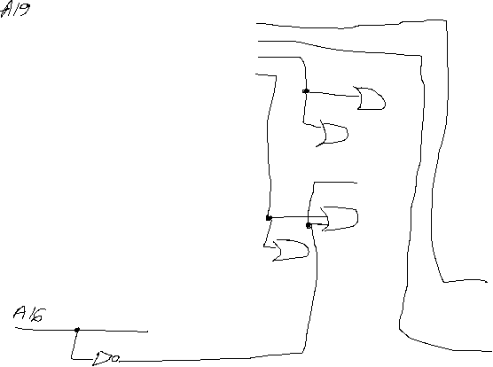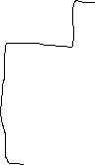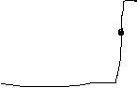

**B6**

**B5**

**B4**

**B3**

**B2**



**- 192KB EEPROM, using 32K x 16 bits memories**

**- 128KB DRAM, using 32K x 8 bits memories**

**STEP 1**

$$EEPROM \# circuits = \frac{192 KB}{32 K * 16 bits}=3$$

$$DRAM \# circuits = \frac{128 KB}{32 K * 8 bits}=4$$

**STEP 2**

$$EEPROM \#\frac{circuits}{block}=\frac{16}{16}=1$$

$$EEPROM \# blocks=\frac{3}{1}=3→B1, B2,B3$$

$$DRAM \#\frac{circuits}{block}=\frac{16}{8}=2$$

$$DRAM \# blocks=\frac{4}{2}=2→B4, B5$$

**STEP 3**

|  |  |  |  |  |
| --- | --- | --- | --- | --- |
| ***BLOCK*** | ***BLOCK SIZE*** | ***ADDRESS LINES*** | ***ADDRESS RANGE*** | |
| B1 | 64 KB | 16 | 0x0000 | 0xFFFF |
| B2 | 64 KB | 16 | 0x0000 | 0xFFFF |
| B3 | 64 kb | 16 | 0x0000 | 0xFFFF |
| B4 | 64 KB | 16 | 0x0000 | 0xFFFF |
| B5 | 64 KB | 16 | 0x0000 | 0xFFFF |

**STEP 4**

|  |  |  |
| --- | --- | --- |
| ***TYPE*** | ***BLOCK*** | ***MEMORY MAP*** |
| EEPROM | B1 | 0x0_0000 |
| 0x0_FFFF |
| B2 | 0x1_0000 |
| 0x1_FFFF |
| DRAM | B3 | 0x2_0000 |
| 0X2_FFFF |
| B4 | 0x3_0000 |
| 0x3_FFFF |
| B3 | 0x4_0000 |
| 0X4_FFFF |

**STEP 5**

|  |  |  |  |  |  |  |  |  |  |
| --- | --- | --- | --- | --- | --- | --- | --- | --- | --- |
| ***A19*** | ***A18*** | ***A17*** | ***A16*** | ***A15*** | ***A14*** | ***...*** | ***A1*** | ***A0*** |  |
| 0 | 0 | 0 | 0 | 0 | 0 | ... | 0 | 0 | ***B1*** |
| 0 | 0 | 0 | 0 | 1 | 1 | 1 | 1 |
| 0 | 0 | 0 | 1 | 0 | 0 | 0 | 0 | ***B2*** |
| 0 | 0 | 0 | 1 | 1 | 1 | 1 | 1 |
| 0 | 0 | 1 | 0 | 0 | 0 | 0 | 0 | ***B3*** |
| 0 | 0 | 1 | 0 | 1 | 1 | 1 | 1 |
| 0 | 0 | 1 | 1 | 0 | 0 | 0 | 0 | ***B4*** |
| 0 | 0 | 1 | 1 | 1 | 1 | 1 | 1 |
| 0 | 1 | 0 | 0 | 0 | 0 | 0 | 0 | ***B5*** |
| 0 | 1 | 0 | 0 | 1 | 1 | 1 | 1 |

**STEP 6**

$$\overline{C_{S1}}=\overline{\overline{A_{19}}∙\overline{A_{18}}∙\overline{A_{17}}∙\overline{A_{16}}}$$

$$\overline{C_{S2}}=\overline{\overline{A_{19}}∙\overline{A_{18}}∙\overline{A_{17}}∙A_{16}}$$

$$\overline{C_{S3}}=\overline{\overline{A_{19}}∙\overline{A_{18}}∙A_{17}∙\overline{A_{16}}}$$

$$\overline{C_{S4}}=\overline{\overline{A_{19}}∙\overline{A_{18}}∙A_{17}∙A_{16}}$$

$$\overline{C_{S5}}=\overline{\overline{A_{19}}∙A_{18}∙\overline{A_{17}}∙\overline{A_{16}}}$$

**STEP 7**



**3-TO-8**

**DECODER**

**B3**

**B4**

**B2**

**B1**

**Design the memory map and memory decoder for a 16 bits microprocessor system using the following memory requirements:**



**B5**

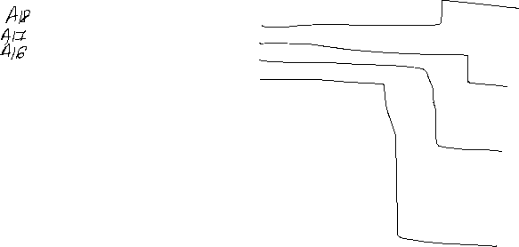

**- 96KB EEPROM ending at FFFFFH, using 16K x 16 bits memories**

**- 128KB DRAM, using 64K x 2 bits memories**

**STEP 1**

$$EEPROM \# circuits = \frac{96 KB}{16 K * 16 bits}=3$$

$$DRAM \# circuits = \frac{128 KB}{64 K * 2 bits}=8$$

**STEP 2**

$$EEPROM \#\frac{circuits}{block}=\frac{16}{16}=1$$

$$EEPROM \# blocks=\frac{3}{1}=3→B1, B2,B3$$

$$DRAM \#\frac{circuits}{block}=\frac{16}{2}=8$$

$$DRAM \# blocks=\frac{8}{8}=1→B4$$

**STEP 3**

|  |  |  |  |  |
| --- | --- | --- | --- | --- |
| ***BLOCK*** | ***BLOCK SIZE*** | ***ADDRESS LINES*** | ***ADDRESS RANGE*** | |
| B1 | 32 KB | 15 | 0x0000 | 0x7FFF |
| B2 | 32 KB | 15 | 0x0000 | 0x7FFF |
| B3 | 32 KB | 15 | 0x0000 | 0x7FFF |
| B4 | 128 KB | 17 | 0x0_0000 | 0x1_FFFF |

**STEP 4**

|  |  |  |
| --- | --- | --- |
| ***TYPE*** | ***BLOCK*** | ***MEMORY MAP*** |
| DRAM | B4 | 0x0_0000 |
| 0x1_FFFF |
| . . . | | |
| EEPROM | B1 | 0xE_8000 |
| 0xE_FFFF |
| B2 | 0xF_0000 |
| 0xF_7FFF |
| B3 | 0xF_8000 |
| 0xF_FFFF |

**STEP 5**

|  |  |  |  |  |  |  |  |  |  |  |  |
| --- | --- | --- | --- | --- | --- | --- | --- | --- | --- | --- | --- |
| ***A19*** | ***A18*** | ***A17*** | ***A16*** | ***A15*** | ***A14*** | ***A13*** | ***A12*** | ***...*** | ***A1*** | ***A0*** |  |
| 0 | 0 | 0 | 0 | 0 | 0 | 0 | 0 | ... | 0 | 0 | ***B4*** |
| 0 | 0 | 0 | 1 | 1 | 1 | 1 | 1 | 1 | 1 |
| 1 | 1 | 1 | 0 | 1 | 0 | 0 | 0 | 0 | 0 | ***B1*** |
| 1 | 1 | 1 | 0 | 1 | 1 | 1 | 1 | 1 | 1 |
| 1 | 1 | 1 | 1 | 0 | 0 | 0 | 0 | 0 | 0 | ***B2*** |
| 1 | 1 | 1 | 1 | 0 | 1 | 1 | 1 | 1 | 1 |
| 1 | 1 | 1 | 1 | 1 | 0 | 0 | 0 | 0 | 0 | ***B3*** |
| 1 | 1 | 1 | 1 | 1 | 1 | 1 | 1 | 1 | 1 |

**STEP 6**

$$\overline{C_{S1}}=\overline{A_{19}∙A_{18}∙A_{17}∙\overline{A_{16}}∙A_{15}}$$

$$\overline{C_{S2}}=\overline{A_{19}∙A_{18}∙A_{17}∙A_{16}∙\overline{A_{15}}}$$

$$\overline{C_{S3}}=\overline{A_{19}∙A_{18}∙A_{17}∙A_{16}∙A_{15}}$$

$$\overline{C_{S4}}=\overline{\overline{A_{19}}∙\overline{A_{18}}∙\overline{A_{17}}∙}$$

**STEP 7**



**3-TO-8**

**DECODER**

**B3**

**B4**

**B2**

**B1**

